- \Operation\Product hopper – monitoring, fill level\Settings
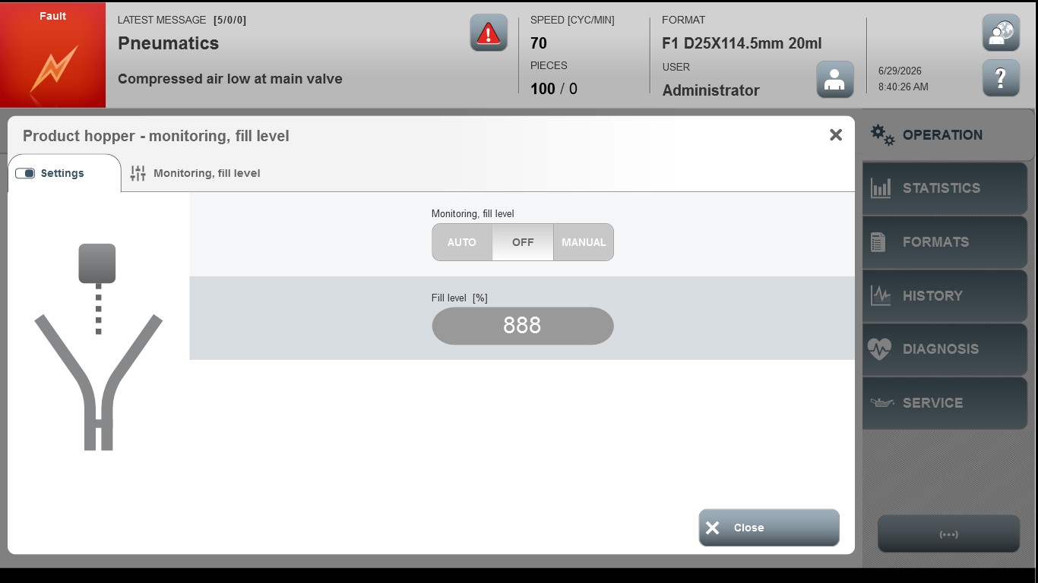
Acceptance criterion | Limits | Pass / Fail: Dev-No. | Date | Initials
Screen matches screenshot | N / A

